|  |  |  |  |  |  |  |  |  |  |
| --- | --- | --- | --- | --- | --- | --- | --- | --- | --- |
| REV No | DATE | | | COMMENTS | | | | | |
| 0 | 05/2020 | | | INITIAL SUBMITTAL TO CLASS | | | | | |
|  |  | | |  | | | | | |
|  |  | | |  | | | | | |
|  |  | | |  | | | | | |
|  |  | | |  | | | | | |
|  |  | | |  | | | | | |
|  |  | | |  | | | | | |
|  |  | | |  | | | | | |
| No of pages (incl. cover): 19 | | | | | | | | | |
| 23, Etolikou Str.  185 45 Piraeus, GREECE  Tel: +30-210-40 63 000  www.bvsolutions-m-o.com | | | | | | ALL RIGHTS RESERVED. NO PART OF THIS DRAWING MAY BE REPRODUCED, STORED IN A RETRIEVAL SYSTEM OR TRANSMITTED IN ANY FORM OR BY ANY MEANS ELECTRONIC, MECHANICAL, PHOTOCOPYING. RECORDING, OR OTHERWISE WITHOUT THE PRIOR PERMISSION OF BV SOLUTIONS M&O. | | | |
| HULL NUMBER:  **1516 / 1515** | | | SHIPYARD:  **SAMSUNG HEAVY INDUSTRIES CO., LTD** | | | | SHIPS NAME:  **OLYMPIC LEADER / OLYMPIC LOYALTY II** | | |
|  | | |  | | | |  | | |
| TITLE: | | | | | | | | | |
| PRESSURE DROP CALCULATION FOR THE WBTS RETROFIT | | | | | | | | | |
| SCALE:  **-** | | DWG No:  **PD-001** | | | JOB No:  **TEC XX/XX** | | | DATE:  **05/2020** | REV. No:  **0** |
|  | |  | | |  | | |  |  |



# Scope - Operational Conditions

The scope of this study is to estimate the total head loss caused during ballasting operation taking into account the additional piping network of the water ballast treatment unit installed on the subjected vessels.

Two worst case scenarios were investigated to this scope.

Scenario No1, covering a path from both No1 and No2 ballast pumps to No1 Water Ballast Tanks, with a loading rate of 2 x 2000 cubic meters per hour.

Scenario No2, covering a path from No2 Ballast pump to the Fore Peak Tank using the port side branch of ballast line, with a loading rate of 2000 cubic meters per hour.

The head loss calculation is divided in two main parts, losses that comes from the friction of the flow of ballast water and losses that comes from the elevation difference between the sea water line under consideration and the top of the air flow of the filling tank.

For the calculation of the first part the “FLOW OF FLUIDS through Valves, Fittings and Pipe” (Crane Technical Paper No. 410M) has been taken into account.

Based on data provided by the maker of the water treatment unit the head loss on each AFU is 0.2bar = 2.039m H20.

The elevation difference have been estimated based on Normal Ballast condition and the geometry of the vessel.

Details for the data used for this analysis and the results will be presented below.

# Network model

For the scope of this analysis part of the existing ballast network including the new pipes for the installation of the water ballast treatment of the vessel has been modelled in a specific head loss calculation software.

This pipe network has been split into six major branches where each branch is indicated by a capital letter from A to F.

Each element of this branch is identified by a unique three digits Id number where the first number of this Id represents the branch where the element belongs while the rest are the ordered position of the element in the branch. For example the element with id 203, belong to branch B and it is the third element from the start of that branch.

Details of this network are presented at the figures that follows:

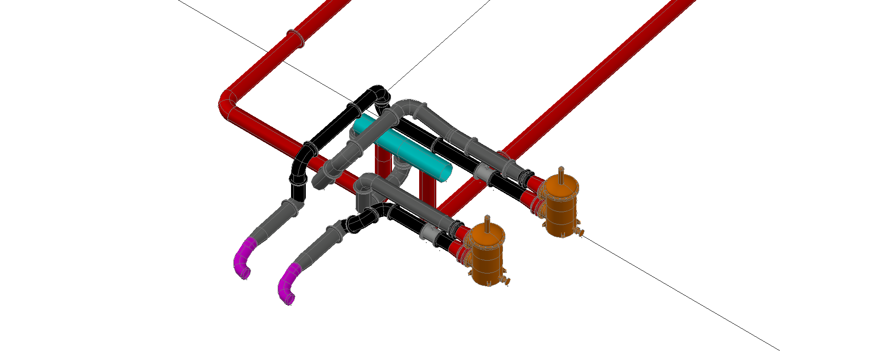

3D model of the ballast network inside Pump Room.

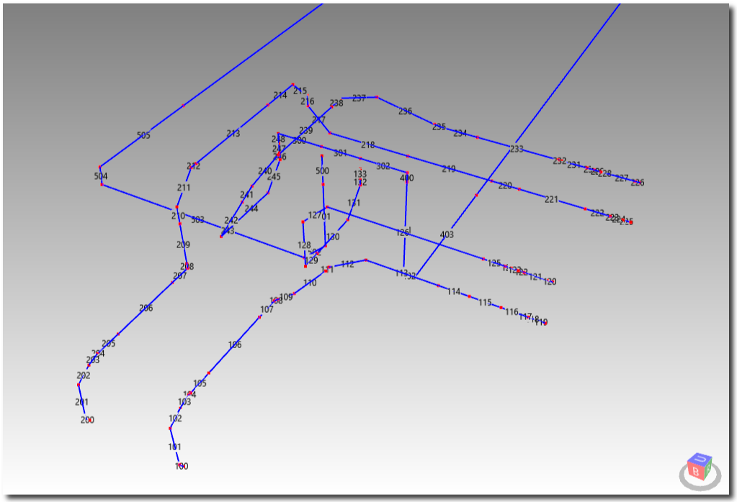

Equivalent calculation model inside Pump Room

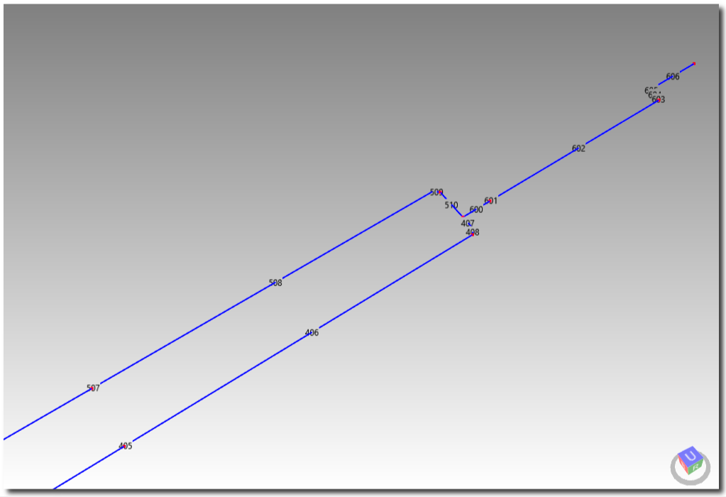

Equivalent calculation model for Ballast Tanks Area.

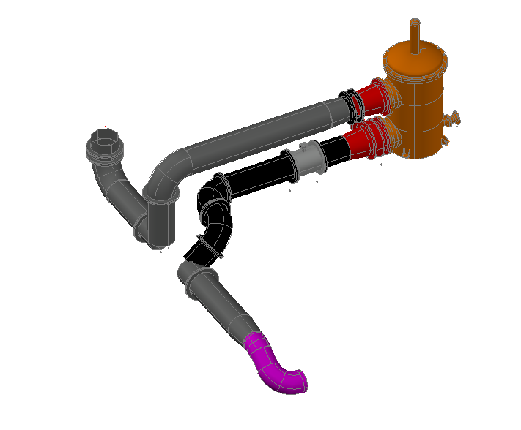

Branch A: Path from discharge of No1 Ballast to common manifold. (3D Model)

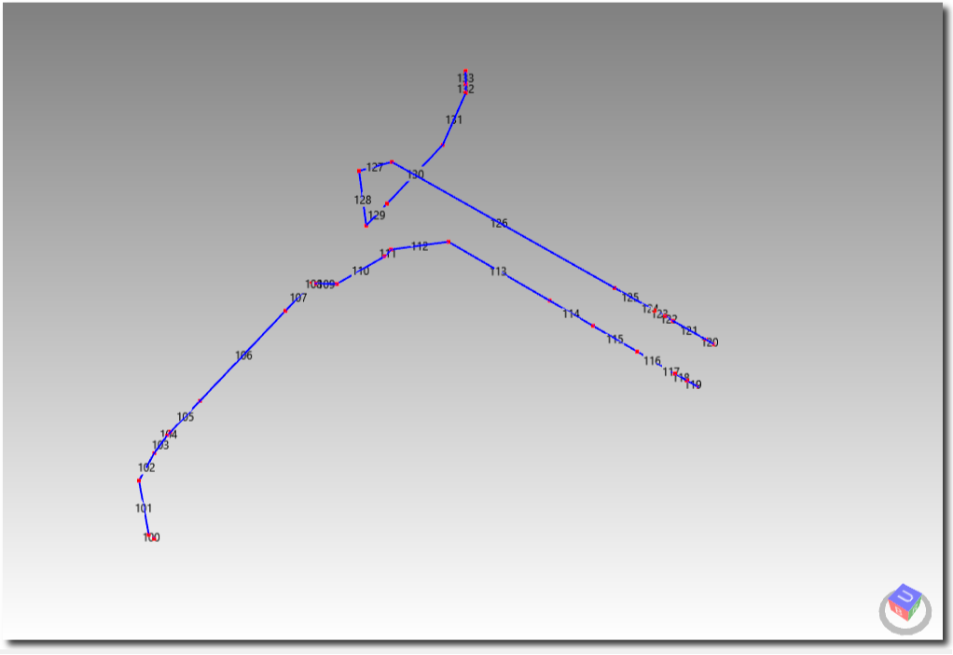

Equivalent calculation model for Branch A. (elements 100 to 133)

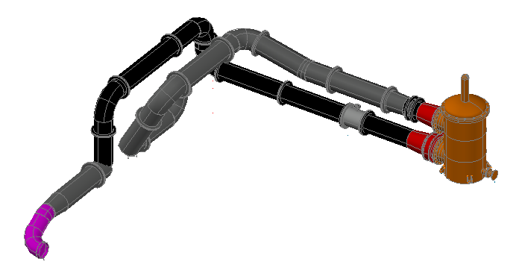

Branch B: Path from discharge of No2 Ballast to common manifold. (3D Model)

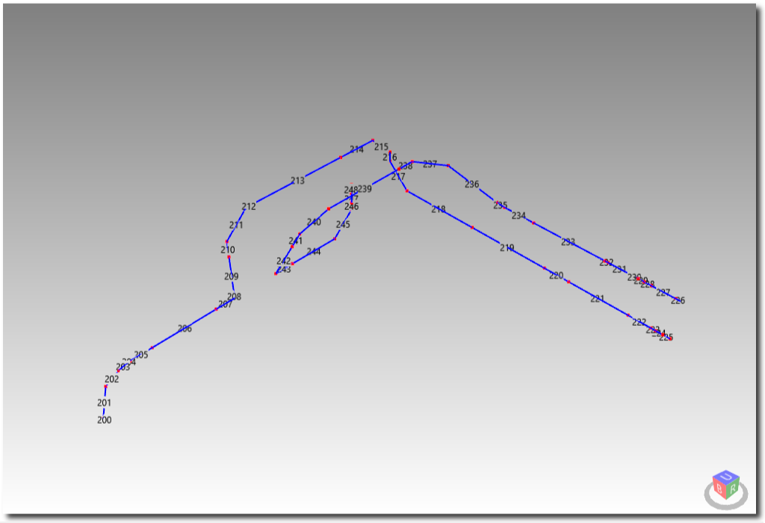

Equivalent calculation model for Branch B. (elements 200 to 248)

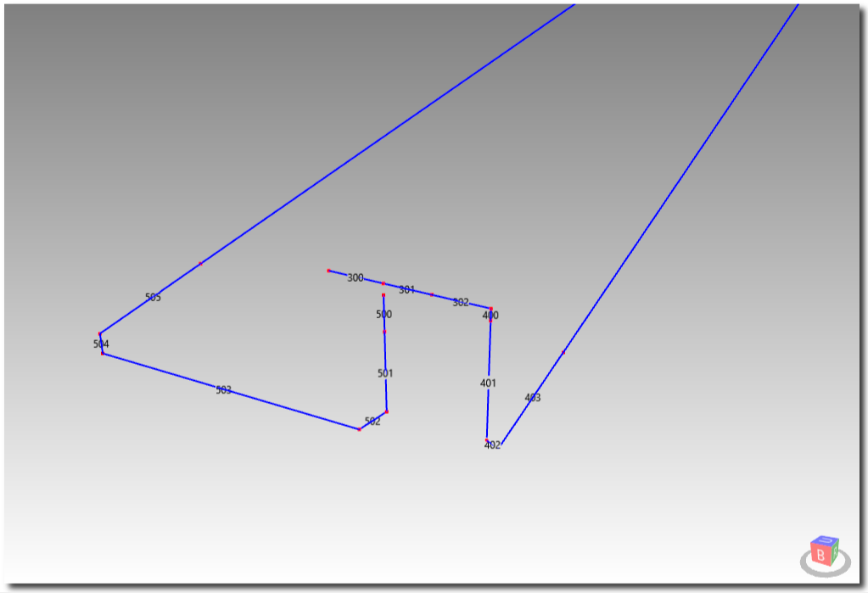

Equivalent calculation model for Branch C. (elements 300 to 302)

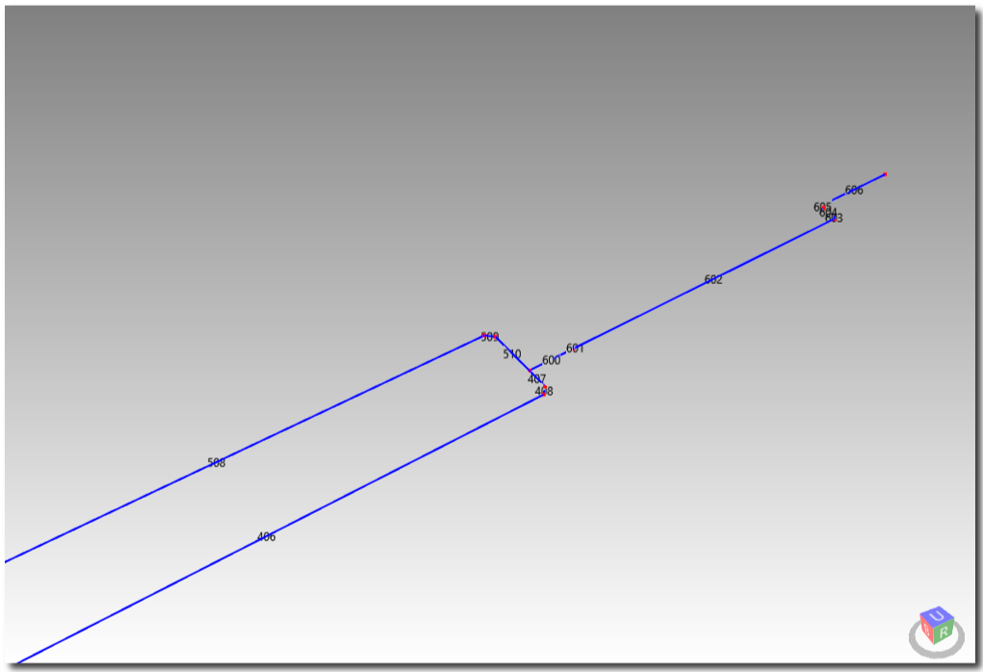

Equivalent calculation model for Branches D, E & F. (elements 400 to 407, 500 to 510 and 600 to 606)

# Scenario 1

The total head loss in mH20 is:

|  |  |  |
| --- | --- | --- |
| New AFU: | 2.034 x 2 | 4.068 |
| Due to friction |  | 5.964 |
| Due to elevation difference* | 31.250 + 0.760 - 5.000 | 27.010 |
|  | | **37.042** |

* The elevation difference is the distance between the top of air pipe of WBT and the sea water line at Light Ship condition.

The available head of the ballast pumps at this flow rate is about **38.000** mH20 as it can be seen from the attached curve below.









# Scenario 2

The total head loss in mH20 is:

|  |  |  |
| --- | --- | --- |
| New AFU: | 2.034 x 2 | 4.068 |
| Due to friction |  | 5.265 |
| Due to elevation difference* | 31.250 + 0.760 - 5.000 | 27.010 |
|  | | **36.403** |

* The elevation difference is the distance between the top of air pipe of WBT and the sea water line at Light Ship condition.

The available head of the ballast pumps at this flow rate is about **38.000** mH20 as it can be seen from the attached curve below.









|  |  |
| --- | --- |
| Id | Element Id |
| Path | Path Id |
| Qh | Rate of flow at flowing conditions m3/h |
| Type | Fitting Type |
| L | Length of pipe (m). |
| d | Internal diameter (mm) |
| d1 | Reducer/Expander small diameter d1 in [mm] |
| d2 | Reducer/Expander large diameter d2 in [mm] |
| r | Bend radius r in [mm] |
| n | Number of bends n |
| a | Miter Bend angle a in [deg] |
| ρ | ρ, water density kg/m3 |
| μ | μ, Dynamic viscosity in cP |
| ν | ν, Kinematic viscosity in cSt |
| Re | Reynolds number (unit less) |
| v | v, mean flow velocity m/sec |
| f | Colebrook equation friction factor |
| fT | Completely turbulent friction factor |
| K | Resistance coefficient |
| hLoss | Loss of static pressure head due to fluid flow [mm] |

